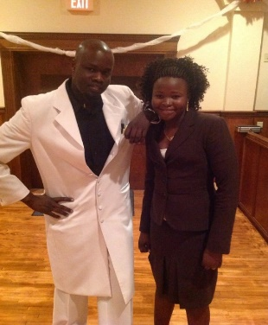 “Endorsement Statement for a Courageous Leader”

Twi Community Association-USA, 2019 Campaign has just kicked off
First off, let me share my background with you. My name is Aguer Ajang Aguer, from Kongor County, Jonglei States, South Sudan. I have lived in the United States for 18 plus. I have been married to my beautiful wife, Elizabeth Abuk Ajang for over 14 years. We have five daughters and two sons.

I have received my highest academic degree, the Doctorate of Philosophy in Higher Educational Leadership from Trident University International, Cypress, California in July 2016. My doctoral dissertation, Title “The Impacts of Quality Teaching on Student Satisfaction in Higher Education in South Sudan (with the data being collected at University of Juba), one of five public universities in the country, details available on my website: https://drjacobaguerajang.com/.

I am exceptionally well organized and a resourceful professional working for the United States Department of Agriculture (USDA) as a Consumer Safety Inspector and possess over 10 years community based organizations’ leadership experiences.

My voluntary work involvements for the community organizations include working as an internship client specialist at Family Lutheran Services to ensure refugees or new comers who come to the United States as refugees due to political background or asylum receive service assistance during their first six months of arrival; worked as a Chairman for the Board of Directors with the Kongor Development Association (KDA),USA to support and sustain the work of KDA as well as providing governing leadership and strategic fundraising support; worked as an Early Head Start Policy Council (PC) with the Omaha Public Schools Head Start (OPSHS) to develop a partnership with parents and staff in making decisions about program changes and policies; worked as treasurer with the Nebraska Community by ensuring that effective financial systems and procedures have been established, are being consistently followed and are in line with best practice and legal requirements; and shortly relieved for 6 years working as a Chairman of the West Community Initiative to “Keep the South Sudanese Culture Alive in the Diaspora” and ensuring that the Board of Directors and Executive Officials are aware to fulfill their governing responsibilities, are accountable for their performances, comply with applicable and organization bylaws and regulations, conduct board business effectively and efficiently.

I am honored to take this privilege to share my vision for the Twi Community in the United States. It has always been my desire to ensure our community in the United States and across the globe live productively, raising healthy children, and taking pride in their own community. My vision for the next leadership is to see the needs of our people are brought to the attention of the Twic Community Association-USA.

I, Dr. Aguer decided to support Lual Bul.

The right person that I am confidently preparing to give my full support and knowledge, to ensure that the rights and privileges are reserved and to lead the office of TCA-USA for the 2019 quality service is Lual Bul Manyok.

My Support for Lual Bul Manyok

I have known Lual Bul Manyok since 2005, as a young man growing up in the Kakuma Refugee Camp. His aspiration for others is to respect and honestly be acquainted to know their background and relatives. He is a very social man to make friendship with and never attempted to participate in community misunderstandings. He enjoys and take pride in becoming a leader for his people.

Lual Bul Manyok was born to a family with strong traditional backgrounds of chief, Mr. Manyok Duot of Wangulei in Nyuak County, Jonglei State in South Sudan. He is married to his lovely wife, Mrs. Kunjok Garang Atem of Wernyok, They are blessed with two sons: Bul, Manyok and one daughter Alek Lual Bul. Lual Bul graduated with a Bachelor of Science in Criminal Justice from Weber State University, Salt City, Utah in 2008, and currently pursuing a Master’s of Criminal Justice in Management at the same University.

Lual Bul Manyok has a strong faith and highest community service backgrounds that make him a mindful community organizer. His commitments are to serve others and ensure services are made available for his people. His previous leadership experiences show enormous accomplishments including: Two terms President of Ayual Community Development Association (ACDA) from 2011 to 2015; currently, served as the Lost Boys and Girls Association Secretary of Information in Utah; 2 years as Minister of Foreign Affairs in the Office of SPLM Chapter in Utah from 2004 to 2006 and presently, ACDA State Representative in Utah.

Due to these extensive background experiences stated above and his clarity to provide equitable services to our families in the United States and of course, at home, have empowered me to educate our community at large that Lual Bul Manyok will be the next president to lead TCA-USA.

In the length of time that I have known him, he has exhibited great passion and strong leadership skills in his role as a community leader.

- I have known him for his willingness to facilitate and keep strong communications and relationships within the organization is awesome;

- I have known him that his assurance to ensure his community expectations and projects are timely follow;

- I have known him that his ability to understand organizational projects are being proposed in a timely and coordinated with members, respectfully.

This is a short list of things that I always expect from a leader in order to gain my support. We’re in tough times that only reasonable leaders can set directional vision for the organization.

In the next few weeks as our campaign goes on the “Twi United Campaign” will be addressing and discussing many concerns that have been limiting and resulted in the organization loosing resources here at home. I have been around enough and fully understand why we have inadequate services in our organizations. Due to these limitations our families and vulnerable people have lost trust and faith in the organization.

I have prepared this endorsement statement to the best of my ability and am looking forward to informing you of other related information. This is to ensure that the community we love has fully gained and understood the reality about Lual Bul Manyok.

I am aware of the quality that a leader of our community needs today. I will stand along with him to ensure that my knowledge and background of being a community organizer and experienced leader can be utilized as needed. This document is being provided to inform the public that once again, our fellow brother Mr. Lual Bul Manyok has taken the privilege to run for 2019 Twi Community Association-USA office.

Our team is grateful for the opportunity to bring this important news to our organization and community members, friends and everyone else here in the United and across the globe. Please I ask every Twic member to understand his based knowledge and willingness to make a difference and his focus on achievable objectives.

This endorsement came from me, but the team will issue a public statement that all the activities being covered in this campaign, including Platform and other campaign related activities and projects. I have served in so many community based organizations and my target has always been to achieve objectives.
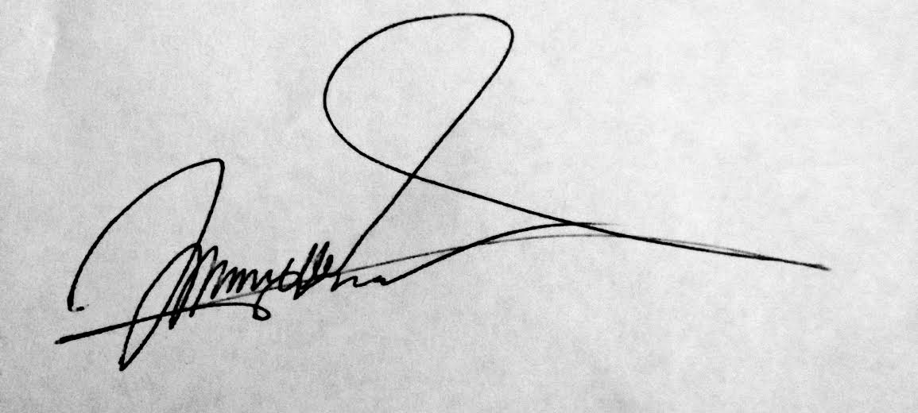
Best regards,

Jacob Aguer Ajang, Ph.D.
Email: aguerajang@hotmail.com

